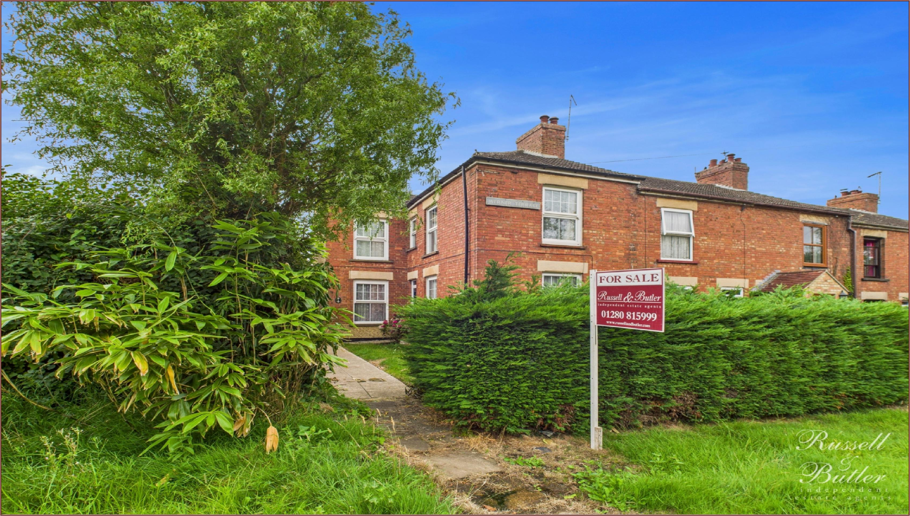

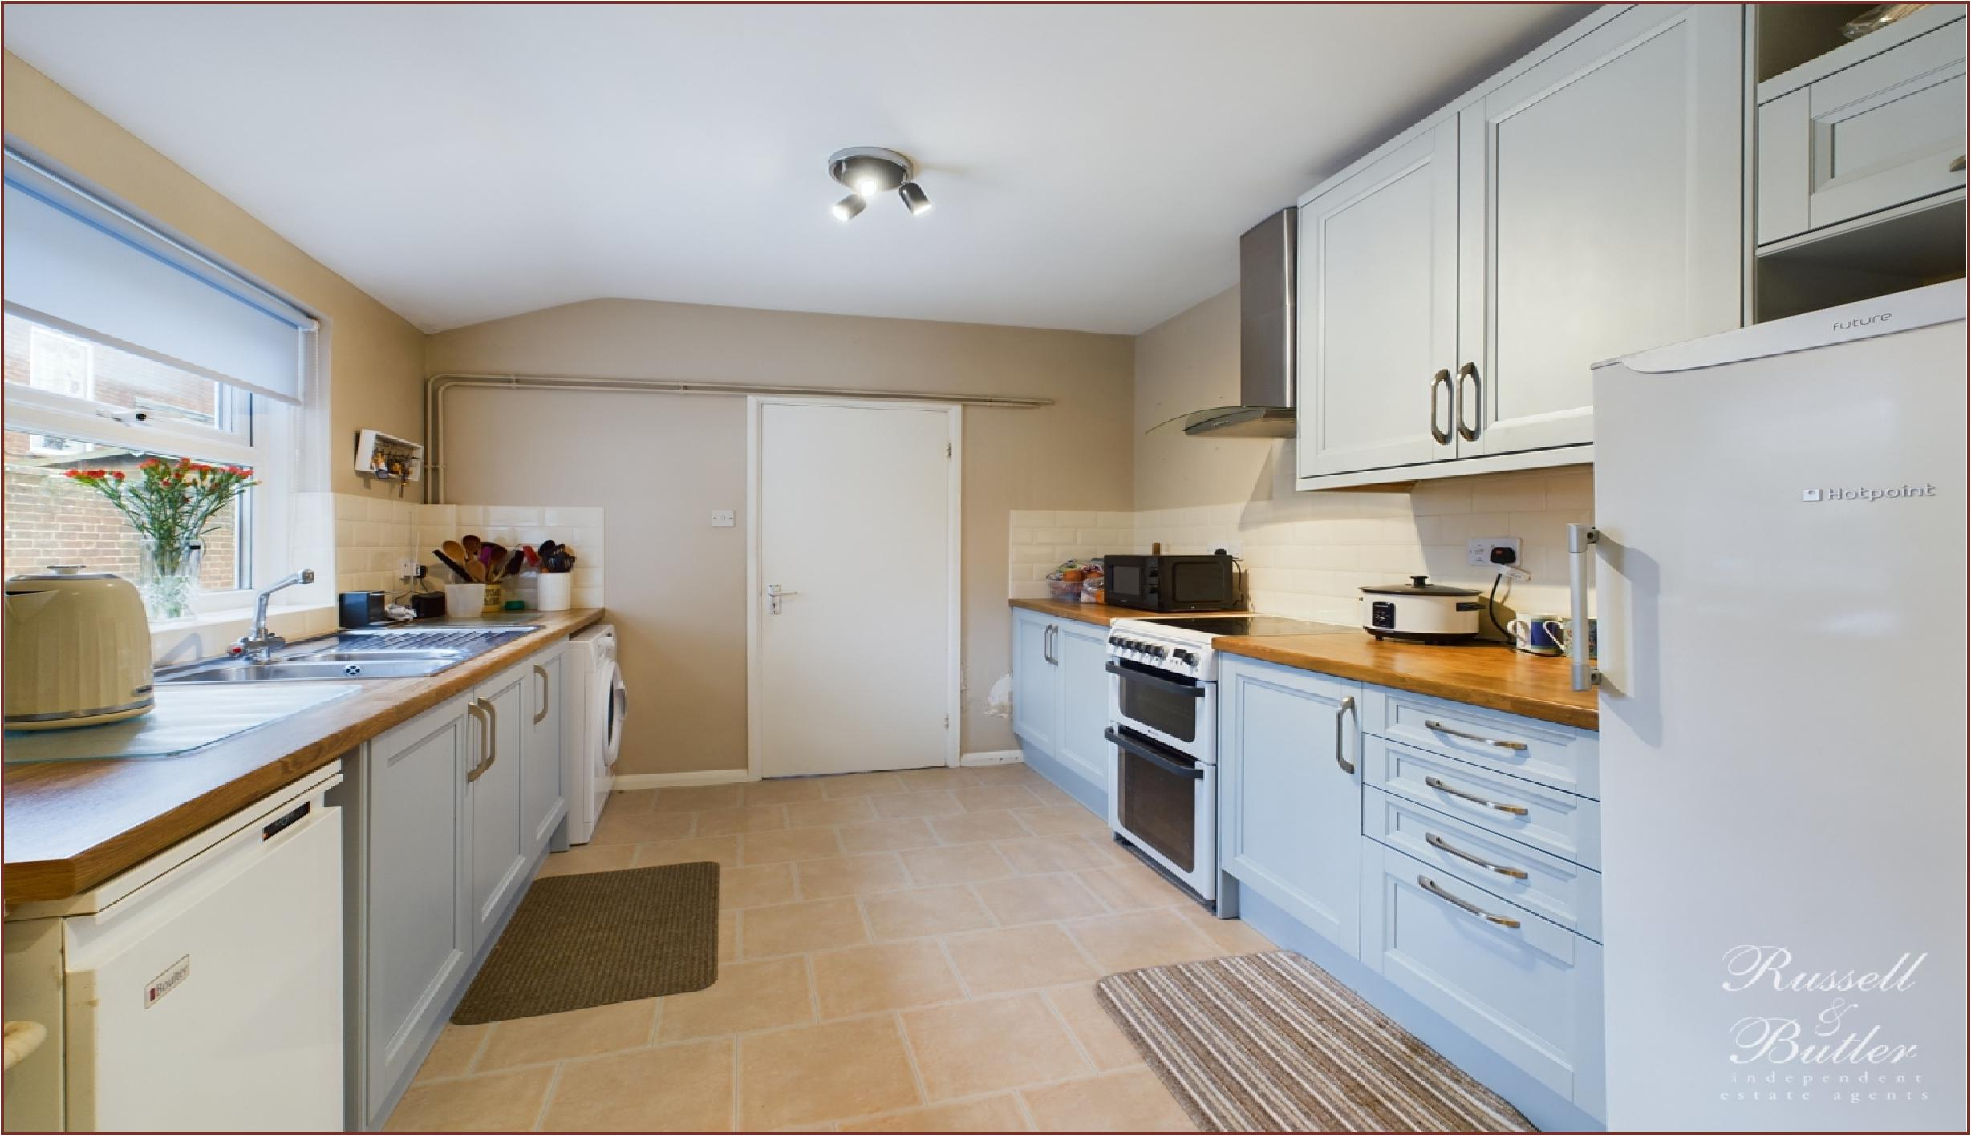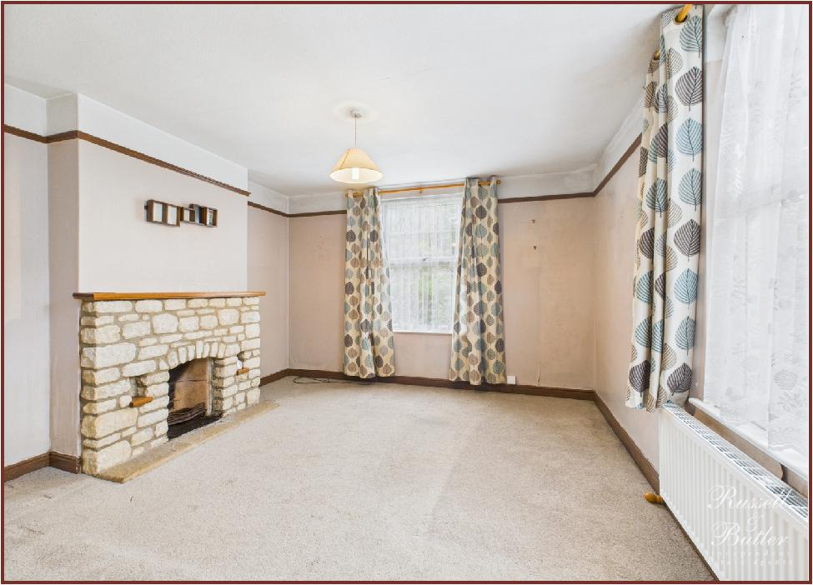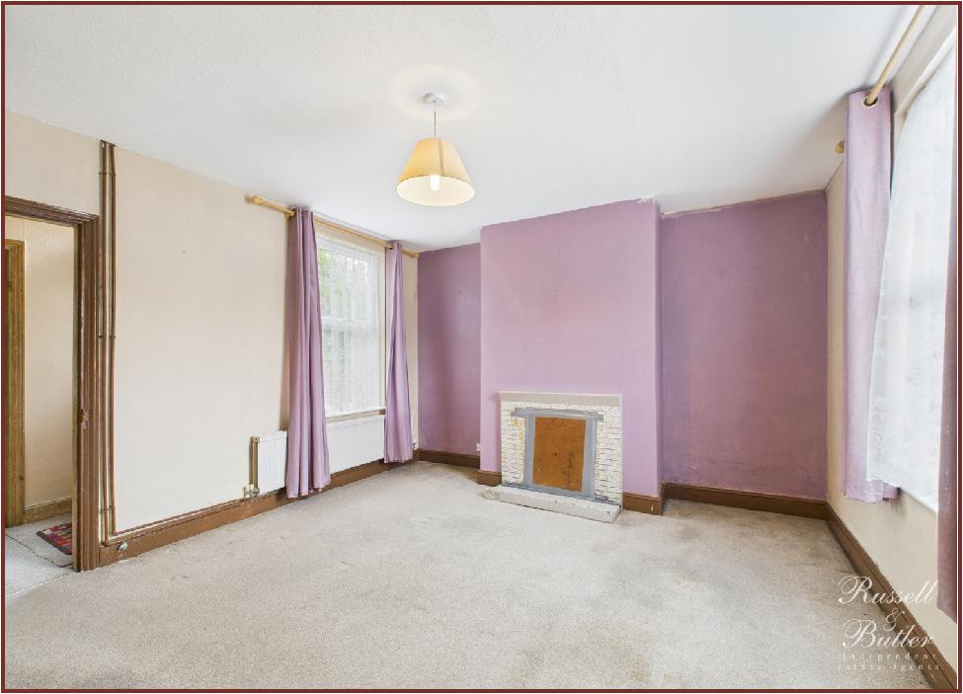

**Werner Terrace, Calvert, Buckingham, MK18 2HQ.**

**Freehold** **£289,995**

A three bedroom Victorian end of terrace house offered with oil to radiator central heating, UPVC double glazing, two reception rooms, attractive fitted kitchen, front and rear garden and off road parking. The accommodation comprises: Entrance Hall, sitting room with open fire, dining room with open fire, kitchen, rear hall, ground floor bathroom, three bedrooms, gardens to front and rear and parking. No onward chain. Council Tax Band C. Energy rating E.

**Bedroom Three**

*9' 9" X 7' 4" (2.98m X 2.25m)*

Radiator. UPVC double glazed window to rear aspect.

**Outside**

**Front Garden**

Laid to lawn with flower and shrub borders. Enclosed by hedge and wall. Path to entrance and side access leading to rear garden.

**Rear Garden**

Laid partly to shingle with large paved patio. New oil storage tank. Timber storage shed.

Parking to rear with vehicular access via Brackley Lane.

**Please Note**

All mains services connected except for gas. Oil central heating.

EPC Rating: E.

Council Tax Band: C.

Construction type: Standard.

BROADBAND/MOBILE COVERAGE: Standard, Superfast and Ultrafast broadband available. Offering highest speeds of 8000Mbps download and 900Mbps upload speeds. The speeds indicated are the fastest estimated speeds predicted by the network operator(s) providing services in this area. Actual service availability at a property or speeds received may be different. 4G likely depending on provider, signal strength varies whether inside or outside. (Information obtained from Ofcom).

Parking: To Rear.

Measurements on floor plan are approximate due to amongst other things wall thickness etc. These are therefore not to be relied on.

Mortgage Advice

If you require a mortgage, we highly recommend that you speak to our Independent Mortgage Adviser Clare Jarvis. Clare is associated with Mortgage Advice Bureau which is one of the largest and best broker firms in the country, having access to the whole of market and due to the volume of mortgages they place often get exclusive rates not available to others too. Please contact us for further information.

**Entrance**

Composite double glazed entrance door to:

**Entrance Hall**

Stairs to first floor. Radiator. Doors to Sitting Room and Dining Room.

**Sitting Room**

*12' 6" X 11' 11" (3.82m X 3.64m)*

Stone built open fireplace. Two UPVC double glazed windows to front and side aspects.

**Dining Room**

*12' 1" X 11' 10" (3.69m X 3.63m)*

Open fireplace. Radiator. Two UPVC double glazed windows to front and rear aspects.

**Kitchen**

*19' 10" X 9' 2" (6.05m X 2.80m)*

Fitted to comprise: Inset single drainer stainless steel sink unit with monobloc mixer tap and a cupboard under. Further range of base and eye level units. Rolled edged work surfaces. Ceramic tiled splash areas. Electric cooker point. Extractor hood over. "Boulter" oil fired boiler serving central heating and domestic hot water. Radiator. Plumbing for automatic washing machine. UPVC double glazed window to side aspect. Door to Rear Lobby.

**Rear Hall**

UPVC double glazed door to garden. Built in storage cupboard. Door to Bathroom.

**Ground Floor Bathroom**

White suite comprising: Panel bath with electric shower over. Wash hand basin with cupboard under. Low level W.C. Full ceramic tiling to all walls. Radiator. UPVC double glazed window to side aspect.

**First Floor Landing**

Access to loft space. radiator. UPVC double glazed window to side aspect.

**Bedroom One**

*12' 6" X 11' 10" (3.82m X 3.63m)*

Radiator. Two UPVC double glazed windows to front and side aspects. Airing cupboard housing hot water tank and immersion heater. Linen shelves as fitted.

**Bedroom Two**

*12' 0" X 11' 11" (3.68m X 3.64m)*

Radiator. Two UPVC double glazed windows to front and rear aspects.

